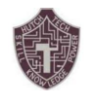 Hutch Tech JROTC April Newsletter 2021
By: Cadet Sergeant Win Oo
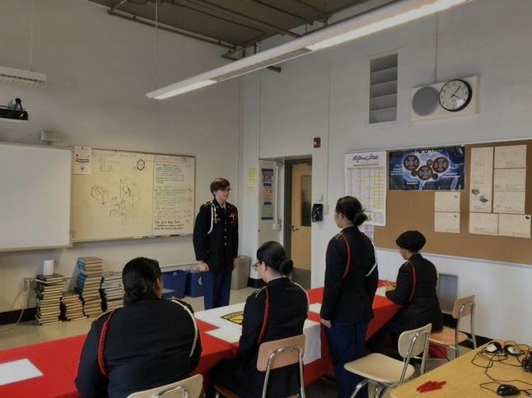
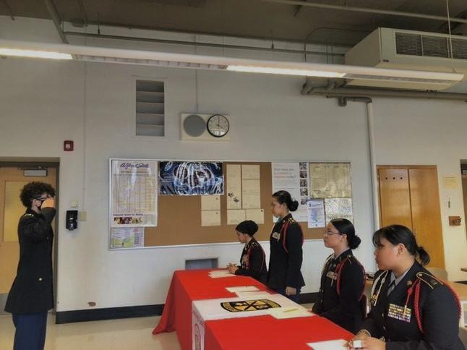

Cadet of The Quarter (COTQ)

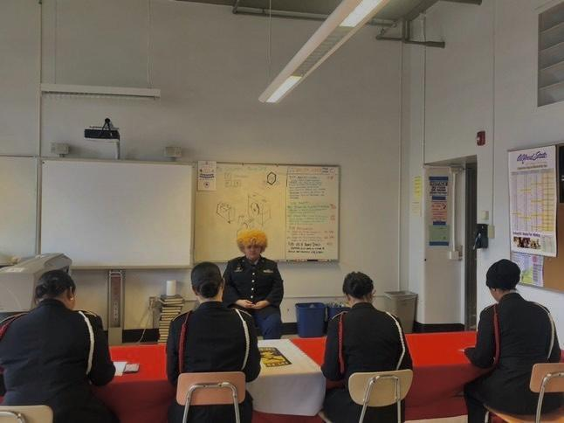
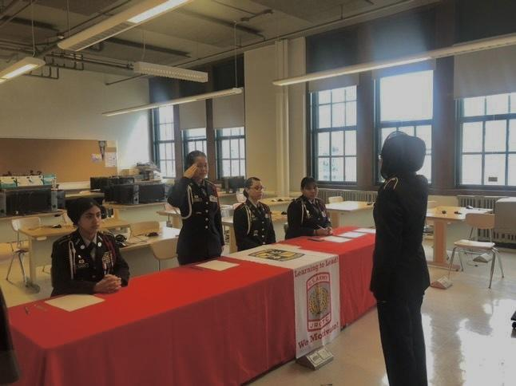
Starting the month off with COTQ, Cadets Tony Figueroa, Michael Chmiola, Diamond Bunch, and Roja Khanam all participated in the competition. Like COTM, they were tested on drill commands by a knockout drill, essays, and were graded on their uniforms. The cadet who had the highest score and won the COTQ was Micheal Chmiola, Overall every cadet did well, great job JROTC cadets.

JPA CIP
On April 20, the Hutch Tech Battalion had their official CIP JPA. Special thanks to Mr. Ivey from the 2nd Brigade, LTC Gosney from Canisius ROTC, COL (R) Abramowitz and assistant principal Estrada for attending to evaluate our JPA. A service learning and a CIP presentation were held after one another, then came the Portfolio team after. Overall with more than a month of practicing for it, the Hutch Tech Battalion passed with a grade of 99.65. Amazing job cadets!
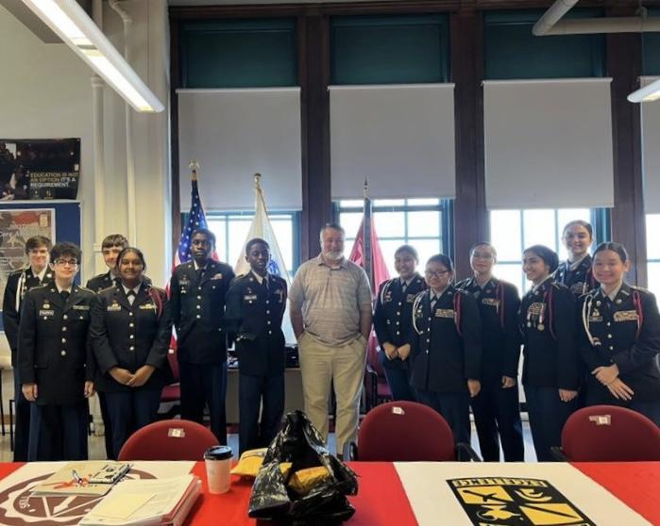
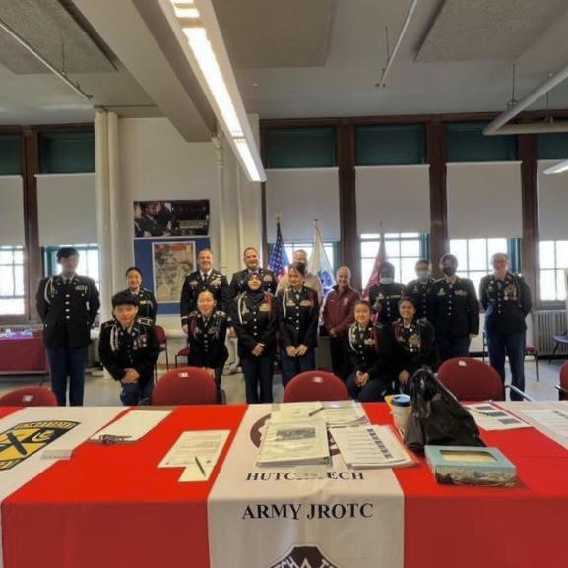

CIP &
Service learning
(Right)

Portfolio
(Left)

April Cadet of The Month
On April 22 Cadet Gavin Banks and Cadet Nadia Dorasami participated in the COTM. They were each tested on knowledge about JROTC, and Government related topics. In the end with a very close score, Cadet Nadia Dorasami was ahead by a tiny bit. Congratulations to these cadets who worked hard on the COTM.
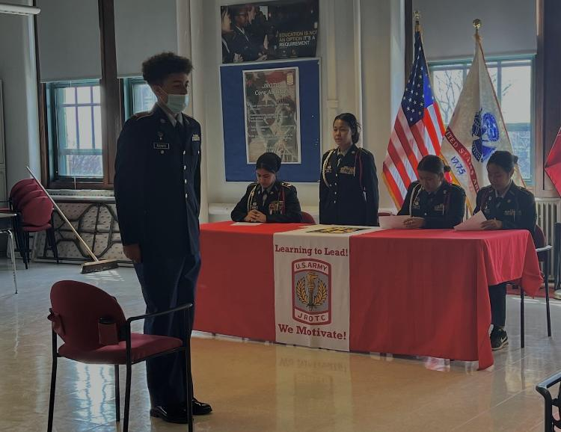
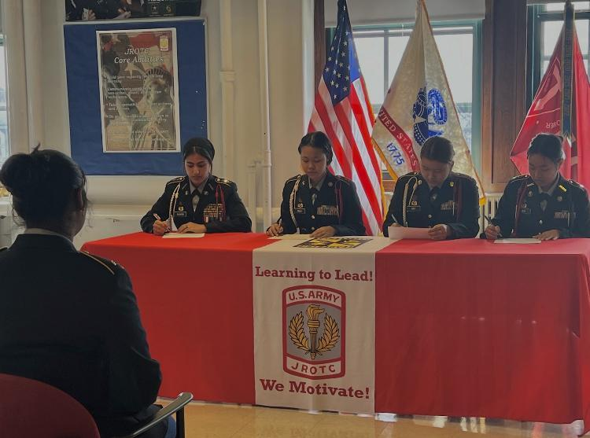
Cadet Banks
(Right)

Cadet Dorasami
(Left)

